2b. SORT AN ARRAY OF DATA IN DESCENDING ORDER

AIM:
To write an assembly language program to sort the array of data in descending order. The array is stored in memory stored in memory starting from 4200H. The first element of the array gives the count value for the number of elements in the array.

APPARATUS REQUIRED:
- 8085 microprocessor kit 1
- Power card 1
- Keyboard 1

ALGORITHM:
- Load the count value from memory to A-register and save it in B-register
- Decrement B-register (B is a count for (N-1) repetitions)
- Set HL pair as data address pointer
- Set C-register as counter for (N-1) comparisons.
- Load a data of the array in accumulator using the data address pointer
- Increment the HL pair (data address pointer)
- Compare the data pointed by HL wait accumulator
- If carry flag is reset (If content of accumulator is larger than memory) then go to step
otherwise go to next step
- Exchange the content of memory pointed by HL and the accumulator
- Decrement C-register. If zero flag is reset go to step 6 otherwise go to next step
- Decrement B-register. If zero flag is reset go the step 3 otherwise go to next step
- Stop.

Output:

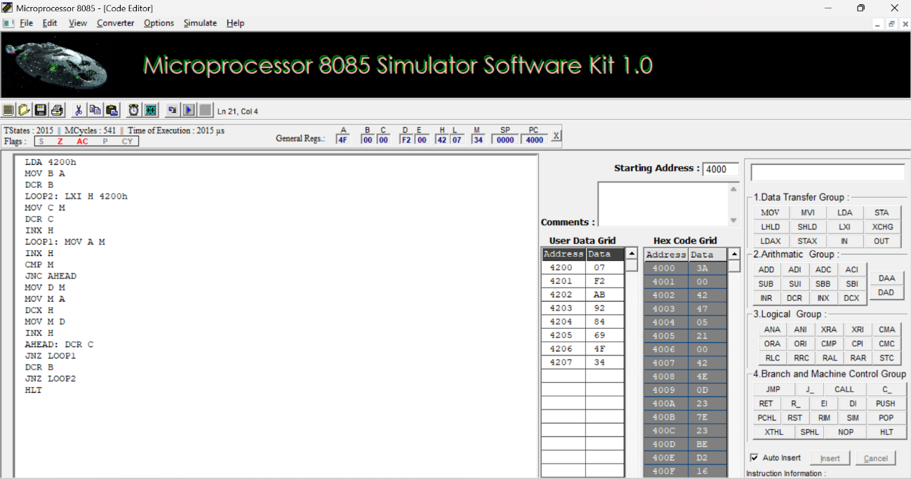

RESULT:
Thus, an assembly language program for sorting in descending order of an unsorted array of 8-bit numbers was written, executed and Verified the Result successfully using 8085 kit.

